1. **Basic Concepts**

* **Chance Experiment:**

There is ________________ about which of two or more possible ___________ will result.

**?** When a single coin (a fair coin) is flipped, do we know in advance what the result of a particular roll will be?

* **Outcome:**

An **outcome** of a chance experiment is one of the things that can happen when you do the experiment.

**?** Consider rolling both a red die and a green die. How many possible outcomes in all?

* **Sample Space:**

A _____ of ____ possible outcomes of an experiment.

* **Event:**

An event is a ______________ of ________________ from the sample space of a chance experiment.

* Practice: Rolling a six-sided fair die.

Outcomes: _________

Sample Space: ___________

The event that the number of face is even: ______

* **Complement:**

The event _____________ consists of all experimental outcomes that are _____ in event A.

Not A is sometimes called the complement of A and is usually denoted by $_______________________$.

* **Union:**

The event __________________ consists of all experimental outcomes that are in at least one of the two events, that is, in A or in B or in both of these.

A or B is called the ___________ of the two events and is denoted by ___________.

* **Intersection:**

The event ___________ consists of all experimental outcomes that are in both of the events A and B. A and B is called the ____________________ of the two events and is denoted by _______________.

* **Venn Diagram:**

In a Venn diagram, the collection of **_____ possible outcomes** is typically shown as the **interior of a _________**. Other events are then identified by specified regions inside this rectangle.

* Draw a Venn Diagram of **A** and **not A.**
* What is the Venn Diagram of …?

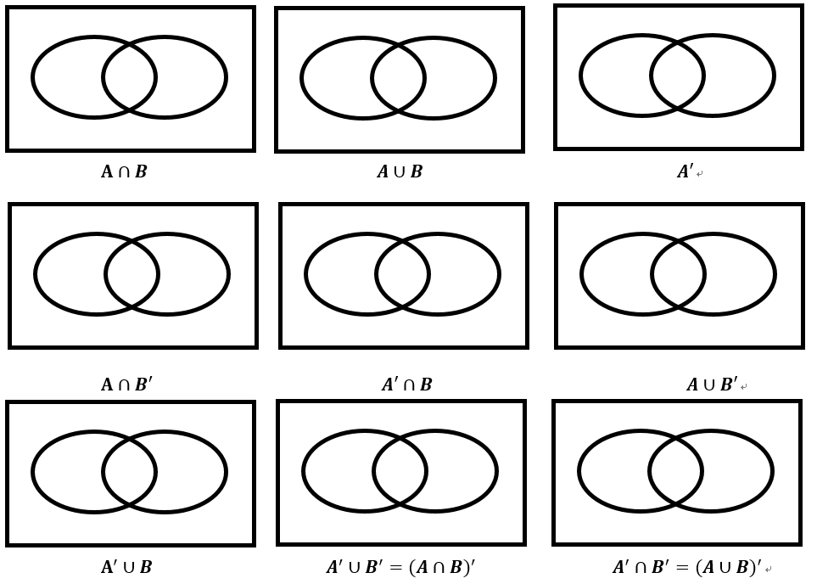

* **Mutually Exclusive ( )**
* **Probability (of an event):**
* In the dice-rolling example, suppose we define event *A* as “sum is 5”. What is the value of P(A)?

Suppose event *B* is defined as “sum is not 5”. What is P(*B)?*

* You have a fair coin. You flip it 10 times.

In which situation is getting tails (T) on your next flip more likely?

Situation 1: HTTHHTHTHT

Situation 2: HTTHHHHHHH

The probability change because of previous results.

* **The Law of Large Numbers**

After many **trials**, the _____________________ of outcomes will approach their **__________________.**

* There are 8 red marbles and 12 blue marbles in a jar. What is the probability of selecting a red marble from the jar?

1. **Properties of Probabilities**
2. For any event A, P(A) $∈$
3. If S is the sample space for an experiment, P(S)=
4. For any event A, P(A)+P(A’)=

Therefore, P(A’)= P(A)=

1. If two events E and F are disjoint, then P(E or F) =

* Not disjoint: P(E or F)=

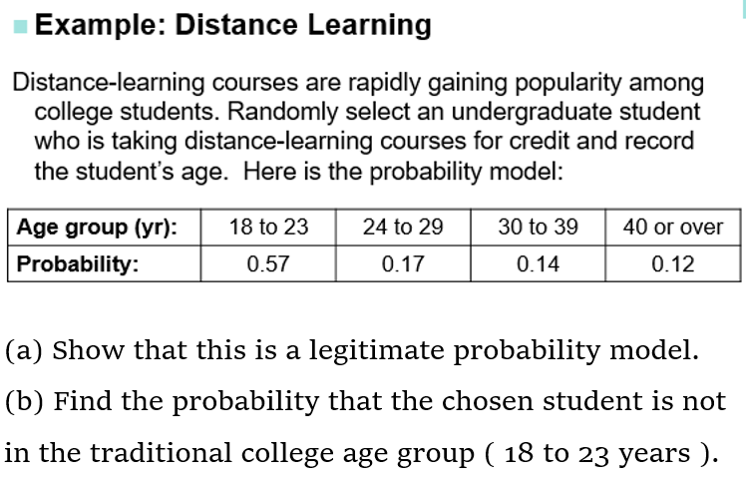

(a) Show that this is a legitimate probability model.

(b) Find the probability that the chosen student is not in the traditional college age group ( 18 to 23 years ).

Homework:

1. Consider the chance experiment in which the type of transmission—automatic (A) or manual (M)—is recorded for each of the next two cars purchased from a certain dealer.
2. What is the set of all possible outcomes (the sample space)?
3. List the outcomes in each of the following events.
4. the event that at least one car has an automatic transmission
5. C the event that exactly one car has an automatic transmission
6. **D** the event that neither car has an automatic transmission
7. What outcomes are in the event B and C? In the event B or C?
8. A new model of laptop computer can be ordered with one of three screen sizes (10 inches, 12 inches, 15 inches) and one of four hard drive sizes (50 GB, 100 GB, 150 GB, and 200 GB). Consider the chance experiment in which a laptop order is selected and the screen size and hard drive size are recorded.
9. Let A be the event that the order is for a laptop with a screen size of 12 inches or smaller. Let B be the event that the order is for a laptop with a hard drive size of at most 100 GB. What outcomes are in A**’** ? In $A∪ B$? In $A∩ B$?
10. Let C denote the event that the order is for a laptop with a 200 GB hard drive. Are A and C disjoint events? Are B and C disjoint?
11. A bookstore sells two types of books (fiction and nonfiction) in several formats (hardcover, paperback, digital, and audio). For the chance experiment that consists of observing the type and format of a single-book purchase, two possible outcomes are a hardcover fiction book and an audio nonfiction book
12. There are eight outcomes in the sample space for this experiment. List these possible outcomes.
13. Do you think it is reasonable to think that the outcomes for this experiment would be equally likely? Explain.
14. For customers who purchase a single book, the estimated probabilities for the different possible outcomes are given in the cells of the accompanying table. What is the probability that a randomly selected single-book purchase will be for a book in print format (hardcover or paperback)?